UAV BASED AGRICULTURAL MONITORING



By

ANAS BIN SAEED (2022-Arid-0063)
FAKIHA ATTIQUE (2022-Arid-0080)
MUHAMMAD ABDULLAH (2022-Arid-0101)
MUHAMMAD SAMEER (2022-Arid-0125)

Bachelor of Science in Computer Science

Barani Institute of Information Technology
PMAS Arid Agriculture University Rawalpindi

Fall 2025

UAV BASED AGRICULTURAL MONITORING



A report submitted in partial fulfillment of the requirements for the degree of
Bachelor of Science in Computer Science

Submitted By

ANAS BIN SAEED (2022-Arid-0063)
FAKIHA ATTIQUE (2022-Arid-0080)
MUHAMMAD ABDULLAH (2022-Arid-0101)
MUHAMMAD SAMEER (2022-Arid-0125)
Bachelor of Science in Computer Science
Supervised By

Dr HASSAN NAZEER CH
Barani Institute of Information Technology PMAS Arid Agriculture University Rawalpindi

Fall 2025

CERTIFICATE
It is certified that the contents and form of thesis entitled “UAV Based Agricultural Monitoring” submitted by Anas Bin Saeed, Fakiha Attique, Muhammad Abdullah, Muhammad Sameer have been found satisfactory for the requirement of the degree.

SUPERVISORY COMMITTEE

PROJECT SUPERVISOR:

Dr Hassan Nazeer Ch.

REPORT COORDINATOR:
Mr. Muhammad Irfan

WRITE-UP COMMITTEE HEAD:
Dr. Mohsin Raza

ACKNOWLEDGEMENT
In The name of Almighty ALLAH, the most beneficent and merciful, who gave us strength and knowledge to complete this project. His guidance and blessings have always been a source and encouragement for us. I pay my heartiest tribute to my supervisor Dr Hassan Nazeer Ch., my report coordinator Mr. Irfan and write up committee head Dr Mohsin Raza for their valuable suggestions, positive criticism and guidance. However, to the people I give deeper and heartfelt gratitude are my teachers. No acknowledgement could ever adequately express my obligation to my group-members who distinctly helped me in all aspects of this work. I owe cordial thanks for their untiring help and good company. Finally, I am grateful to my parents who prayed for me, encouraged and supported me all the way. May Allah bless all of them.

ABSTRACT
"UAV-Based Agricultural Monitoring" is an autonomous aerial monitoring system developed to modernise traditional farming practices through the integration of Unmanned Aerial Vehicles (UAVs), computer vision, and real-time data processing. The system is built using Python as the core processing language, YOLOv8 for object detection, OpenCV for image processing, and a Flutter-based mobile application as the front-end interface for farmer interaction. Agriculture faces critical challenges including illegal water theft, pest infestations, excessive pesticide usage, and undetected crop water stress — all of which lead to significant yield losses and resource wastage. Existing monitoring solutions rely heavily on manual inspection, which is time-consuming, labour-intensive, and often inaccurate. This system addresses these challenges through four integrated tasks. Water Theft Detection employs thermal and RGB imaging to identify unauthorised water diversion along irrigation canals. Pest Detection utilises a deep-learning model deployed on edge hardware to detect and geo-map pest infestations in real time during UAV surveillance flights. Pest Spraying builds upon detection results to autonomously apply pesticide only to infested zones using a variable-rate spraying mechanism, significantly reducing chemical usage. Water Stress Detection uses multispectral imaging to compute NDVI and NDWI indices, generating crop stress maps that enable precision irrigation decisions. The system demonstrated promising results across all four tasks, achieving over 80% detection accuracy for water theft, 75% mAP for pest detection, a 35% reduction in pesticide application, and early water stress identification up to 17–20 days before visible symptoms appear. The proposed platform offers a scalable, cost-effective, and intelligent solution for precision agriculture.

TABLE OF CONTENTS
CERTIFICATE v
ABSTRACT vii
TABLE OF CONTENTS viii
TABLE OF FIGURES ix
Chapter 1 INTRODUCTION 10
1.1 Introductory Background 10
1.2 Problem Statement 10
1.3 Proposed Solution 11
1.4 Objectives 11
1.5 Scope 12
Chapter 2 PROJECT BACKGROUND 13
2.1 Research Articles 13
Chapter 3 CONCEPTUAL DESIGN 15
3.1 Requirements Elicitation 15
3.2 Requirements Specification 15
3.2.1 Functional Requirements 15
3.2.2 Non-Functional Requirements 16
3.2.3 Domain Requirements 16
3.3 Conceptual Diagram 17
3.4 Data Flow Diagram 17
3.4.1 Context Level Diagram 17
3.4.2 Level 1 Diagram: 18
3.5 Database Design 19
3.5.1 Entity Relationship Diagram (ERD) 19
Chapter 4 IMPLEMENTATION 20
4.1 Tools & Technologies 20
4.2 Pseudo Code 20
4.3 Graphical User Interface 28
Chapter 5 CONCLUSION 35
5.1 Conclusion Remarks 35
5.2 Future Directions 35
5.3 Limitations 35
REFERENCES 37
ANNEXURE 38

TABLE OF FIGURES
Figure 3.1: Conceptual Diagram 17

Figure 3.2: Context Level Diagram 18

Figure 3.3: Level 1 Diagram 18

Figure 3.4: Entity Relationship Diagram 19

Figure 4.1: Login Screen (a) Dashboard Screen (b) 28

Figure 4.2: My Drones Screen (a) Farmers Screen (b) Farmer Profile (c) 29

Figure 4.3: Allocate Geofence Screen (a) View Geofence Screen (b) Allocate Day & Time Screen (c) 30

Figure 4.4: Perform Task Screen (a) Water Theft Detection Screen (b) Real Time Processing (Backend) (c) 31

Figure 4.5: Pest Detection Screen (a) Operation Details Screen (b) Pest Log Details Screen (c) 32

Figure 4.6: Water Stress Detection Screen (a) Operation Details Screen (b) 33

Chapter 1
INTRODUCTION

1.1 Introductory Background
"UAV-Based Agricultural Monitoring" is a system developed using Python, YOLOv8, and OpenCV as the core processing stack, with a Flutter-based mobile application serving as the front-end interface for real-time data visualisation and farmer interaction. The system is designed to autonomously monitor agricultural fields through a UAV platform, eliminating the need for manual inspection. Agriculture continues to suffer from persistent challenges including illegal water theft, pest infestations, excessive pesticide usage, and undetected crop water stress — all contributing to significant economic losses. Conventional ground-based monitoring methods are slow, inconsistent, and impractical across large farming areas. This system addresses these challenges by integrating UAV technology with machine learning and multispectral imaging to perform four key operations: water theft detection, pest detection, targeted pest spraying, and crop water stress mapping through NDVI and NDWI analysis. Farmers can monitor all operations through a user-friendly mobile dashboard displaying live telemetry, geo-referenced alerts, infestation heatmaps, and spray logs. The platform is scalable and adaptable, with potential for future expansion into soil health analysis and yield prediction.

1.2 Problem Statement
Agriculture is the backbone of developing economies, yet farmers continue to face critical challenges including illegal water theft from irrigation channels, pest infestations, excessive pesticide usage, and undetected crop water stress — all of which result in significant yield losses and resource wastage. Conventional monitoring methods rely on manual inspection, which is slow, inconsistent, and ineffective across large farming areas. There is a clear need for an integrated, autonomous, and intelligent system capable of detecting and addressing these challenges simultaneously in real time.

1.3 Proposed Solution
The proposed solution to address the challenges faced in modern agriculture is the development of a UAV-Based Agricultural Monitoring System. This system utilizes an autonomous UAV platform equipped with RGB, thermal, and multispectral cameras to continuously monitor farmland without the need for manual inspection. The UAV autonomously patrols irrigation channels to detect unauthorized water theft in real time, alerting farmers instantly through a mobile dashboard. A deep-learning-based pest detection model, deployed on edge hardware, identifies pest infestations during aerial surveys and generates geo-referenced heatmaps to pinpoint affected zones accurately. Building upon pest detection results, the system autonomously executes targeted pesticide spraying only over infested areas through a variable-rate spraying mechanism, significantly reducing chemical usage and environmental impact compared to conventional blanket spraying. Additionally, multispectral imaging enables the computation of vegetation indices such as NDVI and NDWI, allowing the system to detect crop water stress up to 7–10 days before visible symptoms appear, enabling timely and precise irrigation decisions. All data collected during UAV missions is transmitted in real time to a user-friendly mobile application, where farmers can monitor live telemetry, view detection alerts, access stress maps, and review spray logs with ease. The system is designed to be scalable and cost-effective, offering a practical and intelligent solution for precision agriculture that addresses water theft, pest control, pesticide efficiency, and crop health monitoring within a single integrated platform.

1.4 Objectives
Following are the objectives of this project:
- To develop an autonomous UAV-based system for continuous agricultural field monitoring without manual inspection. To get quick response regarding an operation through voice commands.
- To detect unauthorized water theft from irrigation channels in real time and alert farmers instantly.
- To identify and geo-map pest infestations using a deep-learning detection model during aerial surveillance.
- To perform targeted pesticide spraying only over infested zones, minimizing chemical usage and environmental impact.
- To detect crop water stress early through multispectral imaging for timely irrigation decisions.

1.5 Scope
"UAV-Based Agricultural Monitoring" system is specially designed for farmers facing challenges of water theft, pest infestations, and crop water stress. The farmer will interact with the system through a user-friendly mobile dashboard, through which all four monitoring operations can be tracked and managed in real time. It is simple to use due to its intuitive interface and autonomous UAV-based monitoring, making precision agriculture accessible for everyday farming needs.

Chapter 2
PROJECT BACKGROUND

2.1 Research Articles
This project is titled as "UAV-BASED AGRICULTURAL MONITORING". This idea is unique in its nature as no similar integrated study combining all four agricultural challenges has been conducted in the past. It is a new project, developed by researchers Muhammad Abdullah, Anas Bin Saeed, Fakiha Attique, Muhammad Sameer. In this project, the following functionalities are provided: farmers can monitor water theft from irrigation channels in real time using thermal and RGB imaging, enhancing resource protection. The system also offers real-time pest detection capabilities using YOLOv8-based computer vision and autonomous targeted pesticide spraying, providing precise and environmentally friendly pest control. For large-scale agricultural operations, the application incorporates multispectral imaging for water stress detection, allowing early identification of crop health issues through NDVI and NDWI analysis. Additionally, farmers can access geo-referenced heatmaps and create customized mission plans for specific monitoring zones, fostering a more proactive and data-driven approach to farm management.
This system is designed for agricultural communities where farmers struggle with water theft, pest infestations, and crop stress detection. Farmers can monitor all four operations through a mobile dashboard displaying live telemetry, alerts, and spray logs. The system autonomously patrols fields using pre-planned waypoints and performs detection and intervention tasks without manual supervision. This platform is very helpful for resource-limited farmers who can operate the system through a simple mobile interface with minimal technical expertise. The related project that inspired this work is "Precision Agriculture with Drones" which was previously explored in various agricultural research studies. "Precision Agriculture with Drones" was a UAV-based system designed to facilitate farmers with quick access to field health data. Farmers could monitor crop conditions through aerial imaging. This system transformed the functionality of traditional manual scouting into an automated aerial platform with enhanced features like real-time crop health mapping, soil moisture analysis, and anomaly detection. Farmers could also perform functionalities like zone-specific monitoring and create flight paths for targeted surveillance. Users were facilitated through other operations such as switching between different monitoring modes, accessing historical data, and exporting reports for further analysis. Some of the key features of this system include geo-tagging functionality, where farmers can mark any location in the field for detailed inspection at any time. The mission planning feature allows farmers to create sequences of waypoints and execute them autonomously, facilitating consistent monitoring and data collection. Additionally, the multi-sensor integration feature enables farmers to capture data using RGB, thermal, and multispectral cameras, allowing them to choose their preferred sensor configuration and personalize their monitoring strategy according to crop type and environmental conditions.

Chapter 3
CONCEPTUAL DESIGN

This chapter includes the details about the main functional and non-functional requirements of the UAV-Based Agricultural Monitoring system and how the requirements are modeled in the form of system architecture diagrams and data flow diagrams (DFD). It demonstrates how farmers and operators interact with the system to address agricultural challenges through use case diagrams. The chapter also presents the main functionalities of the system — water theft detection, pest detection, autonomous spraying, and water stress mapping — in the form of a conceptual block diagram.

3.1 Requirements Elicitation

Requirement elicitation for the UAV-Based Agricultural Monitoring system involves gathering insights from various stakeholders, including farmers, agronomists, irrigation authorities, and UAV operators, to understand their needs and operational challenges. Techniques such as field visits, stakeholder interviews, focus group discussions, and surveys are employed to collect feedback on key functionalities like water theft detection, pest identification accuracy, autonomous spraying precision, and water stress mapping. The system utilizes tools like JIRA for tracking and managing requirements, along with system workflow mapping to visualize operational sequences and identify technical constraints. This thorough elicitation process ensures the development of a reliable, scalable, and user-centered agricultural monitoring solution.

3.2 Requirements Specification

Following are the requirements specifications of the software that tells what is the scope of the software and what software should do.

3.2.1 Functional Requirements

- The system shall be able to autonomously detect water theft from irrigation channels using thermal and RGB imaging.
- The system shall be able to identify and geo-map pest infestations in real time during aerial surveillance flights.
- The system shall be able to execute targeted pesticide spraying only over pest-infested zones autonomously.
- The system shall be able to detect crop water stress through multispectral imaging and NDVI/NDWI analysis.

3.2.2 Non-Functional Requirements

- Securable
The system will be more secure. The data will be kept safe.
- Portability
For UAV deployment, target platforms are Raspberry Pi and Jetson Nano. Mobile dashboard supports Android and iOS.
- Reliability
The system should never fail more than 1 minute per mission.

3.2.3 Domain Requirements

The domain requirements for the UAV-Based Agricultural Monitoring system focus on delivering an accurate, efficient, and scalable solution for video-based agricultural analysis. The system must provide real-time detection capabilities for water theft, pest infestations, and crop water stress from aerial footage, allow users to annotate detection zones, and generate geo-referenced heatmaps for targeted intervention. It should support batch video processing to analyze multiple surveillance feeds simultaneously, enabling efficient large-scale monitoring. Additionally, the system must offer multispectral image analysis for computing NDVI and NDWI indices to detect water stress early. Compatibility with Python-based frameworks, YOLOv8, OpenCV, and cross-platform deployment (Windows, Linux) are essential for operational flexibility. The interface should prioritize ease of use for farmers and agronomists, including intuitive dashboards and visual detection overlays, while ensuring secure data storage and model inference accuracy.

3.3 Conceptual Diagram
A Conceptual diagram is a visual representation of how a system works. Below is the conceptual diagram of UAV-Based Agricultural Monitoring System.

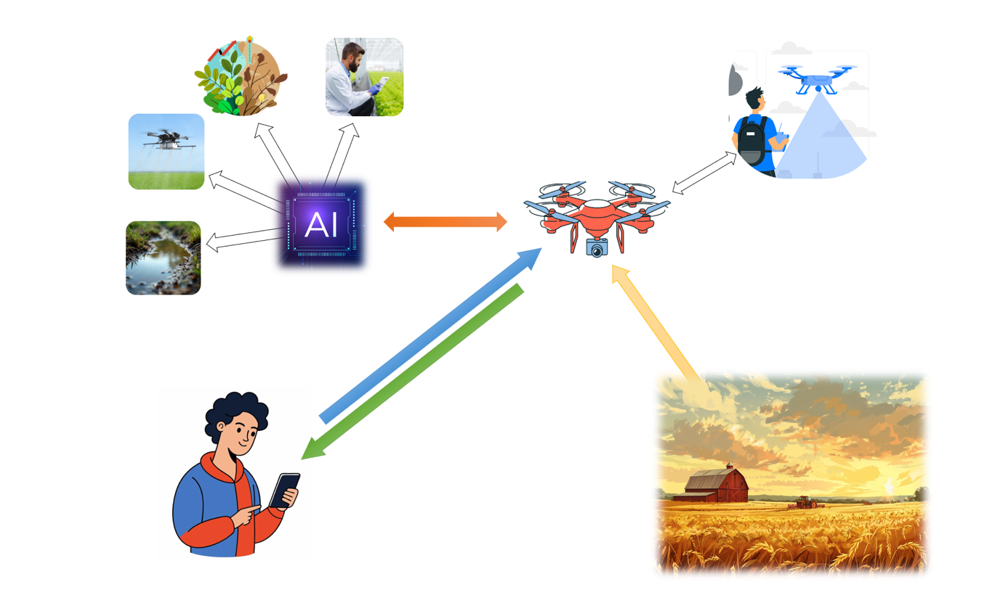
Figure 3.1: Conceptual Diagram

3.4 Data Flow Diagram
Data flow diagram (DFD) is a graphical representation that depicts information flow and the transforms that are applied as data moves from input to output. Data flow diagram is also known as bubble chart and data flow graph. Below is the DFD of the Letters and Words to Picture Association for Slow Learners.

3.4.1 Context Level Diagram
Context level DFD provides an overview of the system and its main components. It shows the high-level flow of data within the system, including the sources and destinations of the data, and the main processes involved. This level of DFD provides a broad understanding of the system and its data flow but does not go into detail about the individual processes and components.
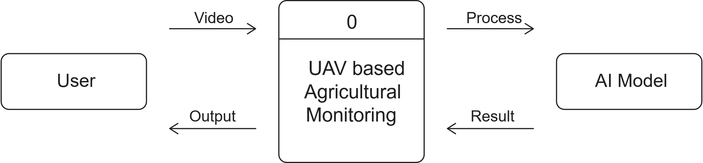
Figure 3.2: Context Level Diagram

Approved By: Dr. Hassan Nazeer Ch.

3.4.2 Level 1 Diagram:
shows the UAV-Based Agricultural Monitoring System decomposed into multiple high-level processes, with its relationship with Farmer/Operator, Database, and Detection Results output interface.

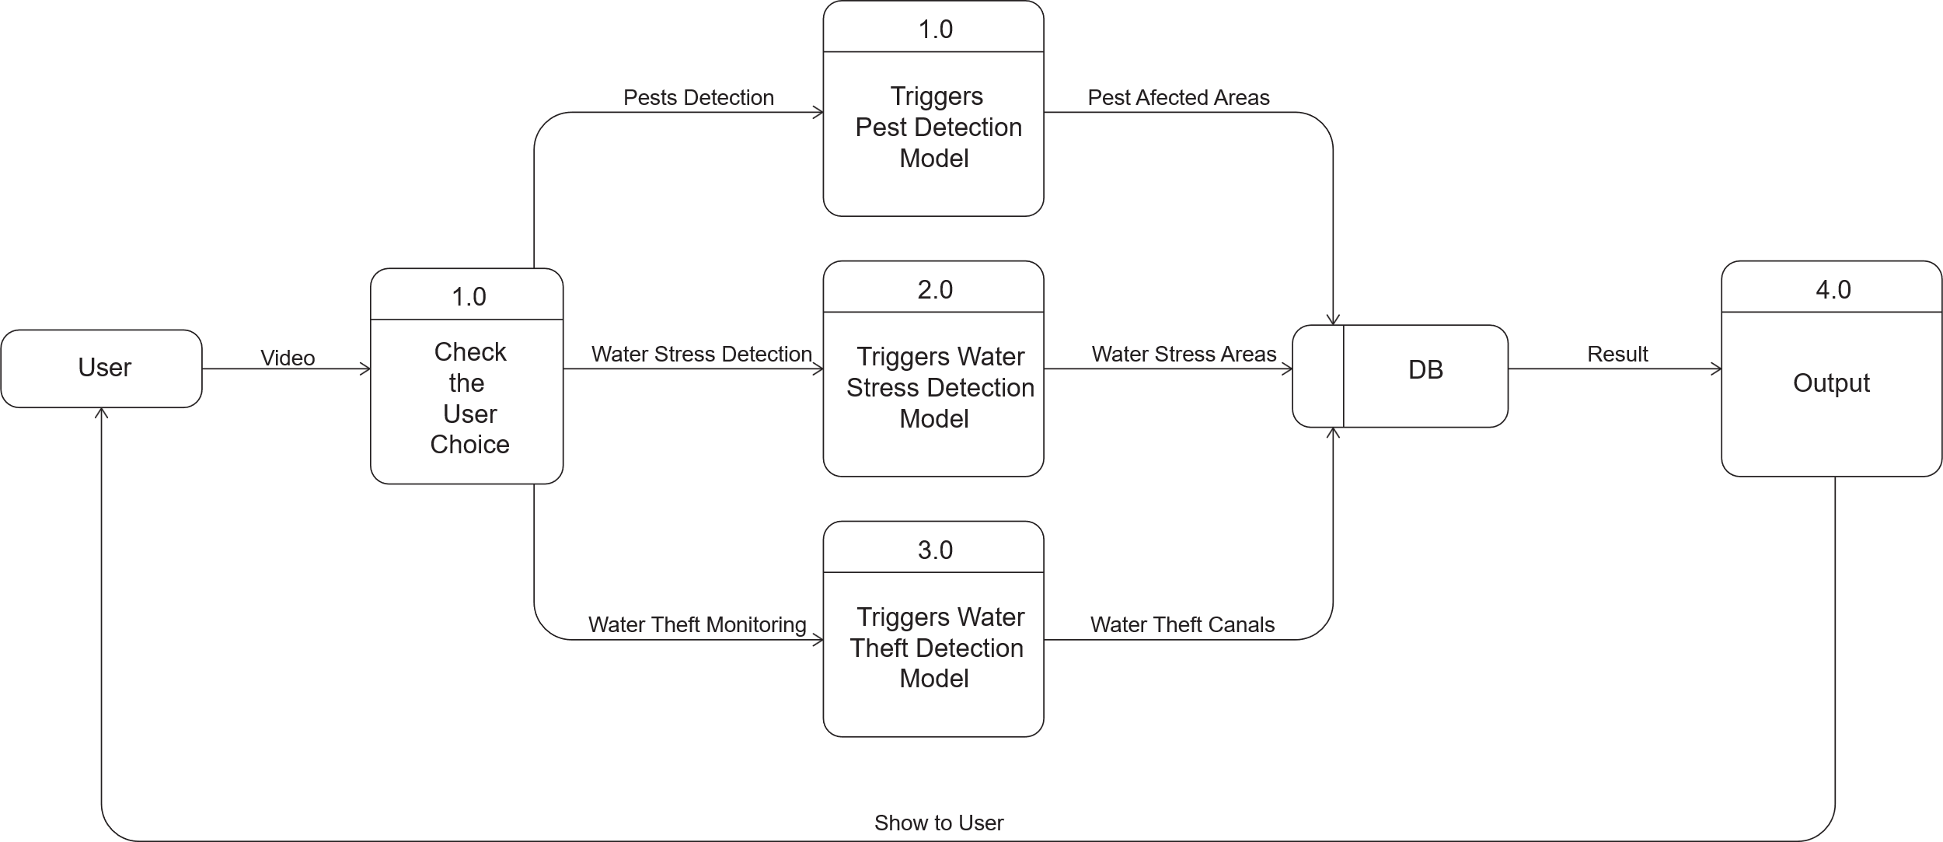
Figure 3.3: Level 1 Diagram

Approved By: Mr. Shahid Jamil

3.5 Database Design

3.5.1 Entity Relationship Diagram (ERD)
An Entity Relationship (ER) Diagram is a type of flowchart that illustrates how “entities” such as people, objects or concepts relate to each other within a system. ER Diagram is most often used to design or debug relational database in the fields of software engineering, business information system, education and research. Also known as ERDs or ER Models, they use a defined set of symbols such as rectangles, diamonds, ovals and connecting lines to depict the interconnectedness of entities, relationships and their attributes. They mirror grammatical structure, with entities as nouns and relationships as verbs.

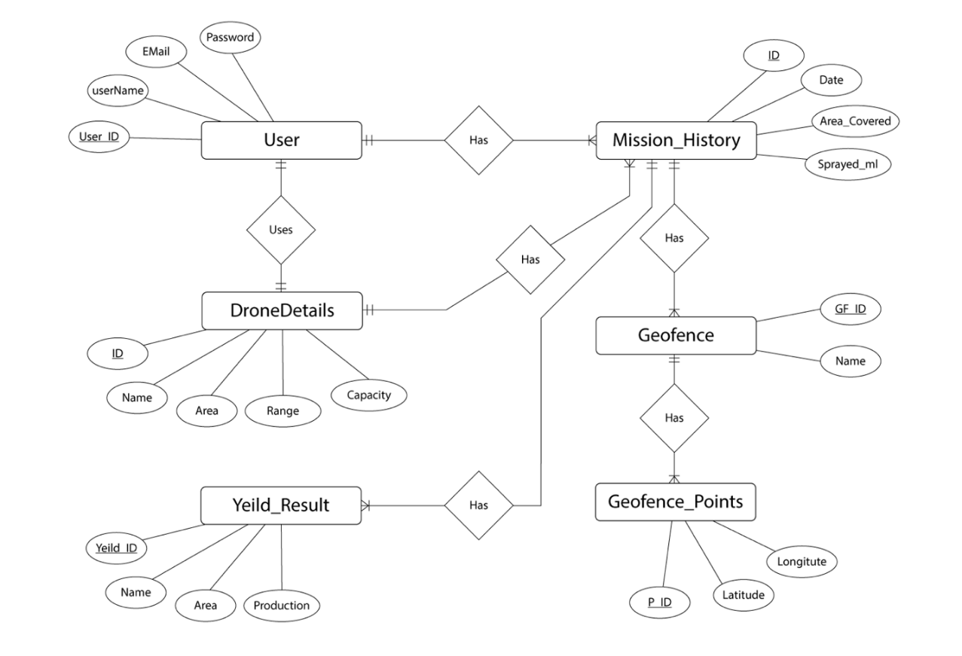
Figure 3.4: Entity Relationship Diagram

Approved By: Mr. Shahid Jamil

Chapter 4
IMPLEMENTATION

This chapter includes the discussion about the Tools and Technologies which have been used for designing of this application. It also includes how the application has been designed through coding. Also, this chapter includes the discussion about graphical user interface, and this can be shown through project screen shots.

4.1 Tools & Technologies
Following Tools and Technologies are used to develop this application.
For Mobile App
    - Android Studio
    - Visual Studio Code
    - Xcode
    - Java Development Kit
    - Flutter (Dart)
    - React Native
    - Swift IOS
    - PyCharm
    - React JS
For Web API
- Python Flask API
- PyCharm
- Python Development Kit

4.2 Pseudo Code
Login Screen:
If (User == Username AND Password) {[Authenticate User] [Store] AdminID globally Go to Dashboard Screen}
If (User == Register Button) {Go to Registration Screen}
else {[Display] "Invalid Username or Password"}

Dashboard Screen:
[Display] Water Thefts Count for current AdminID
[Display] Pests Count for current AdminID
[Display] Stress Areas Count for current AdminID
[Display] Available Drones Count for current AdminID
[Display] Farmers Count for current AdminID
If (User == Water Thefts Section) { [Display] Latest Water Theft Detections
If (User == View All) { Go to Water Theft History Screen } }
If (User == Pest History Section) { [Display] Latest Pest Detections
If (User == View All) { Go to Pest History Screen } }
If (User == Water Stress Section) { [Display] Latest Stress Detections
If (User == View All) { Go to Water Stress History Screen } }
// Bottom Navigation
If (User == Drone Icon) { Go to My Drones Screen }
If (User == Home Icon) { Stay on Dashboard Screen }
If (User == Farmer Icon) { Go to Farmers Screen }
If (User == Hamburger Icon) { [Display] Side Navigation Menu }

My Drones Screen:
[Display] Drones list filtered by AdminID
If (User == Filter Dropdown) {[Display] Filter options: All, Available, Unavailable
If (User == selects filter) { [Filter] Drone list by status } }
If (User == Drone Card) { Go to Drone Details Screen }
If (User == Add Drone Button) { Go to Add Drone Screen }

Add Drone Screen:
If (User == Drone Name AND Range AND Capacity) {[Save] Drone with AdminID
[Display] "Drone Added Successfully" Go to My Drones Screen}
else {[Display] "Please fill all fields"}
Farmers Screen:
[Display] Farmers list filtered by AdminID
If (User == Farmer Card) {Go to Farmer Details Screen}
If (User == Add Farmer Button) {Go to Add Farmer Screen}

Add Farmer Screen:
If (User == Farmer Name AND Username AND Drone) {
[Save] Farmer with AdminID [Display] "Farmer Added Successfully"
Go to Farmers Screen}
else {[Display] "Please fill all fields"}

Farmer Details Screen:
[Display] Farmer Information [Display] Geofences list for this Farmer
If (User == Geofence Card)
{ If (User == View Details) { Go to Geofence Details Screen } }
If (User == Allocate Geofence Button) { Go to New Geofence Screen }
If (User == Delete Farmer Icon) { [Display] Confirmation Dialog
If (User == Confirm) { [Delete] Farmer and associated Geofences Go to Farmers Screen } }

New Geofence Screen:
[Display] Map with zoom controls (+, -)
If (User draws polygon on map) { [Store] Geofence Boundary Points }
If (User clicks Rotate Icon) { [Rotate] Map View } [Display] Geofence Name Input Field
If (User enters Geofence Name) { [Store] Field Name }
If (User clicks Allocate Button)
{ [Save] Geofence to Database Go to Geofence Details Screen }
If (User clicks Clear Markers Button) { [Clear] All drawn boundaries [Reset] Map }
Geofence Details Screen:
[Display] Map with:
- Geofence Boundary (red polygon)
- Zoom Controls
[Display] Allocated Time:
- Day (dropdown)
- Start Time
- End Time
If (User clicks Set Time Buttons) {[Open]Time Picker [Store] Selected Time }
If (User clicks Allocate Day & Time Button)
{ [Save] Schedule to Database Go to Task Selection Screen }
If (User clicks Perform Tasks Button) { Go to Task Selection Screen }
If (User clicks Delete Icon) { [Display] Confirmation Dialog If (User confirms)
{ [Delete] Geofence Record Go back to Farmer Details Screen }}
Task Selection Screen:
[Display] Available Tasks:
- Water Theft Detection
- Pest Detection
- Water Stress Test
If (User clicks Water Theft) { Go to Water Theft Detection Screen }
If (User clicks Pest Detection) { Go to Pest Detection Screen }
If (User clicks Water Stress Test) { Go to Water Stress Detection Screen }
Water Theft Detection Screen:
[Display] Video Thumbnail
If (User clicks Play Button) { [Play] Uploaded Video }
[Display] Video Details Form:
- Start Time
- End Time
- Day (dropdown)
If (User clicks Set Time Buttons) { [Open]Time Picker[Store] Selected Time }
If (User clicks Save Details Button)
{ [Save] Video Metadata to Database
[Display] Processing Started Message
[Send] Video to Flask API
[Call] Water Theft Detection Model
// Backend Processing
[Extract] Frames from Video
[Run] YOLOv8 Water Theft Model
[Generate] Detection Results
[Store] Results in Database
[Display] Processing Complete Notification Go to Water Theft Results Screen }

Water Theft History Screen:
[Display] List of Water Theft Operations:
- Farmer Name
- Field Name
- Date
- Alert Status (Warning Icon if theft detected)
If (User clicks Operation Card) { Go to Water Theft Operation Details Screen }
Water Theft Operation Details Screen:
[Display] Processed Video with detection overlay
[Display] Operation Information:
- Farmer Name
- Geofence Name
- Theft Detected: Yes/No
- Operation Date
If (Theft Detected) { [Display] Alert Banner [Display] Detected Coordinates/Zones }

Pest Detection Screen:
[Display] Video Thumbnail
If (User clicks Play Button) { [Play] Uploaded Video }
If (User clicks Start Processing Button) {
[Save] Video Metadata
[Display] Processing Started Message
[Send] Video to Flask API
[Call] Pest Detection Model (YOLOv8)
Backend Processing:
[Extract] Frames from Video
[Run] YOLOv8 Pest Detection Model
[Calculate] Affected Area Percentage
[Generate] Heatmap with bounding boxes
[Store] Results in Database
[Display] Result Image with:
- Pest Detection Overlay (purple/pink/red zones)
- Affected Area Percentage
- Bounding Box on detected pests
Go to Pest Operation Details Screen }
Pest Operation Details Screen:
[Display] Original Video
[Display] Result Image with Detection Overlay
[Display] Operation Information:
- Farmer Name
- Geofence Name
- Affected Area: 20.1%
- Pest Detected: Yes
- Operation Date
[Display] Pest Logs Section:
- Log ID
- Affected Percentage per scan
- Date
- Status (checkmark if saved)
If (User clicks Perform Another Operation) { Go to Task Selection Screen }
Pest Spraying Screen:
[Display] Video Thumbnail
[Display] Spray Selection Dropdown:
- Choose Spray Type
If (User selects spray type) { [Store] Spray Type }
If (User clicks Start Processing Button) {
[Display] Processing Message
[Identify] Infested Zones from Pest Detection Results
[Generate] Spray Zone Map
[Calculate] Required Spray Volume
[Store] Spray Log Go to Spray Operation Details Screen }
Spray Operation Details Screen:
[Display] Processed Image with Spray Zones
[Display] Operation Information:
- Farmer Name
- Geofence Name
- Affected Area: 20.1%
- Pest Detected: Yes
- Operation Date
[Display] Pest Logs:
- Log ID: 36
- Affected Percentage: 0.9%
- Date: 02-01-2026
- Status: Success (checkmark)
If (User clicks Log) { Go to Log Details Screen }
Log Details Screen:
[Display] Log Information:
- Farmer Name
- Geofence Name
- Affected Area: 0.9%
- Pest Detected: No
- Spray Used: Carbamates
- Operation Date

Water Stress Detection Screen:
[Display] Video Thumbnail
If (User clicks Play Button) { [Play] Uploaded Video }
If (User clicks Start Processing Button) {
[Display] Processing Message
[Send] Video to Flask API
[Call] Water Stress Detection Model
Backend Processing:
[Extract] Frames from Video
[Compute] NDVI and NDWI Indices
[Identify] Stressed Zones (red bounding boxes)
[Generate] Stress Heatmap (green boundary for geofence)
[Store] Results in Database
[Display] Result Image with:
- Stress Detection Overlay
- Red boxes on stressed areas
- Green geofence boundary Go to Stress Operation Details Screen }
Stress Operation Details Screen:
[Display] Processed Image with Stress Zones
[Display] Operation Information:
- Farmer Name
- Geofence Name
- Stress Found: Yes
- Operation Date

Hamburger (Side Menu) Screen:
If (User == Profile) { Go to Profile Screen }
else if (User == Settings) { Go to Settings Screen }
else if (User == Notifications) { Go to Notifications Screen }
else if (User == About Us) { Go to About Us Screen }
else if (User == Logout) {
[Display] Confirmation Dialog
If (User == Confirm) {
[Clear] AdminID session Go to Login Screen } }
Notifications Screen:
[Display] All alerts filtered by AdminID:
- Water Theft Alerts
- Pest Detection Alerts
- Water Stress Alerts
If (User == Notification Card) { Go to respective Operation Details Screen }
If (User == Clear All) { [Clear] All notifications for AdminID }

4.3 Graphical User Interface
This section discusses the GUI of the UAV-Based Agricultural Monitoring System. The first screen is the login screen where operators authenticate using username and password, followed by the dashboard screen displaying statistics for water theft detections, pest counts, water stress areas, available drones, and registered farmers. Users can navigate through the application using the bottom navigation bar (My Drones, Dashboard, Farmers) and the hamburger menu for accessing additional features.
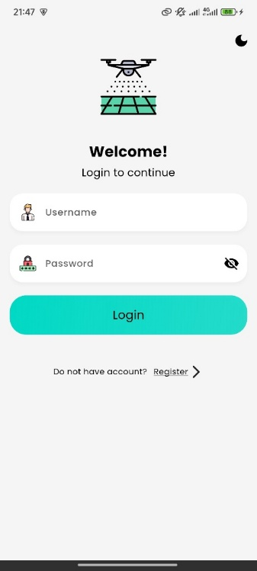 | 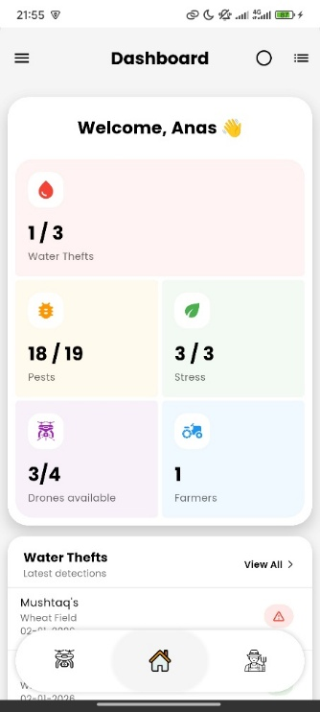
(a) | (b)
Figure 4.1: Login Screen (a) Dashboard Screen (b)
Dashboard Screen:
This screen displays real-time statistics including water theft detections, pest counts, water stress areas, available drones, and registered farmers. User can navigate to detailed history by selecting 'View All' for each category and access additional features through the bottom navigation bar and hamburger menu.

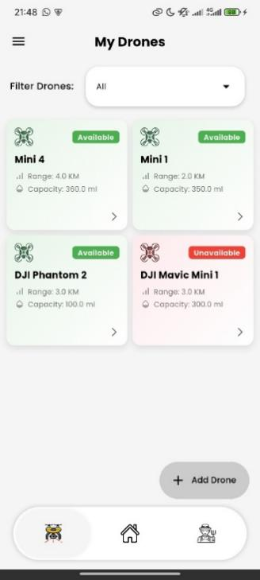 | 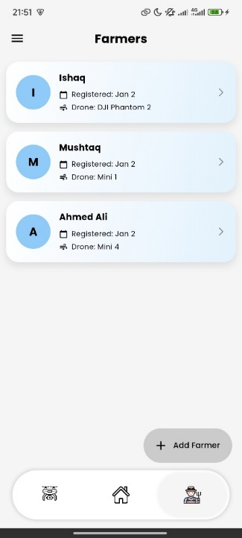 | 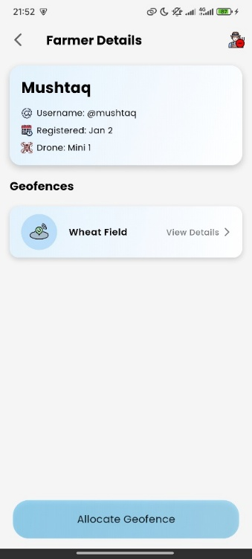
(a) | (b) | (c)
Figure 4.2: My Drones Screen (a) Farmers Screen (b) Farmer Profile (c)
My Drones Screen:
This screen contains a list of registered drones with details such as name, range, capacity, and availability status. User can filter drones by status, view detailed information by selecting a drone card, and add new drones by clicking the 'Add Drone' button.

Farmers Screen:
This screen displays a list of registered farmers showing name, registration date, and assigned drone. User can view detailed farmer information and allocated geofences by selecting a farmer card, and register new farmers by clicking the 'Add Farmer' button.

Farmer Profile:
This screen shows details information of the farmer with all the details and allocated geofences. The new geofence can be added using ‘Allocate Geofence’ button.
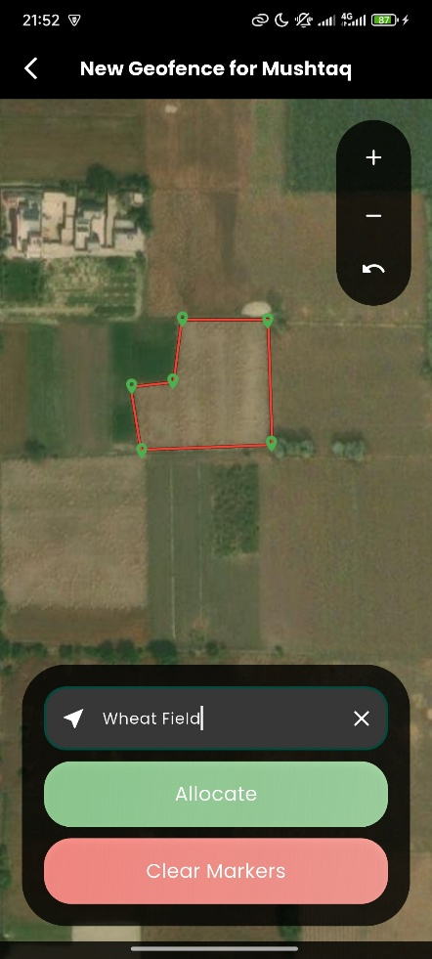 | 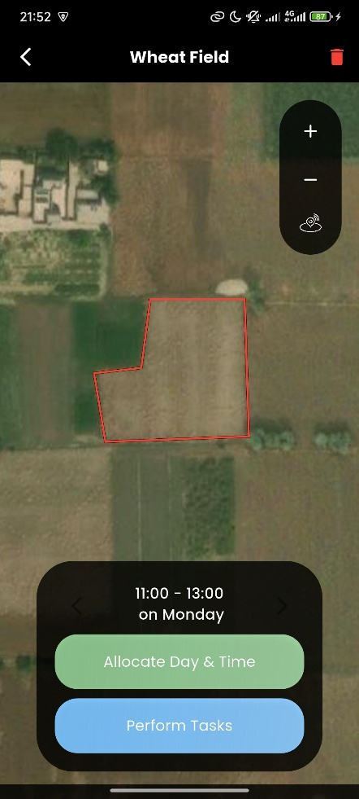 | 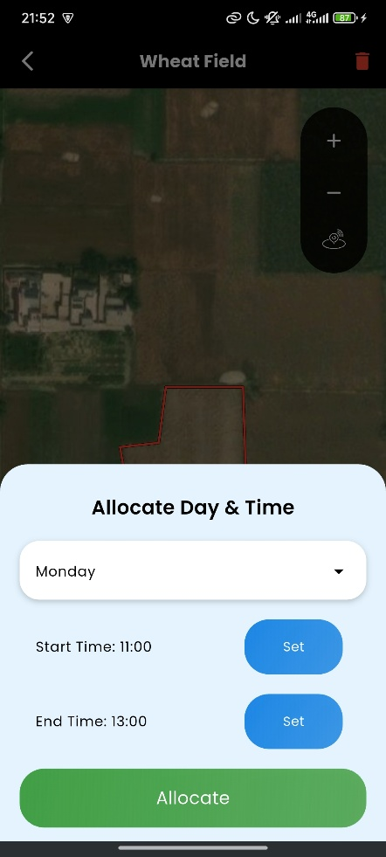
(a) | (b) | (c)
Figure 4.3: Allocate Geofence Screen (a) View Geofence Screen (b) Allocate Day & Time Screen (c)
Allocate Geofence Screen:
This screen contains an interactive Open Street Map where user can draw field boundaries by marking polygon points on satellite view. User can zoom in/out, enter a geofence name, save the boundary, and clear all markers to restart selection.

View Geofence Screen:
This screen displays the selected geofence from farmer profile screen. The user can see name, delete the geofence, zoom in and out, and see and allocate the schedule for that geofence. The screen also allows the user to perform various tasks on the geofence.

Allocate Day & Time Screen:
This screen allows user to allocate the day & time for the geofence. This schedule is later used for water theft detection. The user can select day, start time and end time for that geofence. The schedules can be multiple.
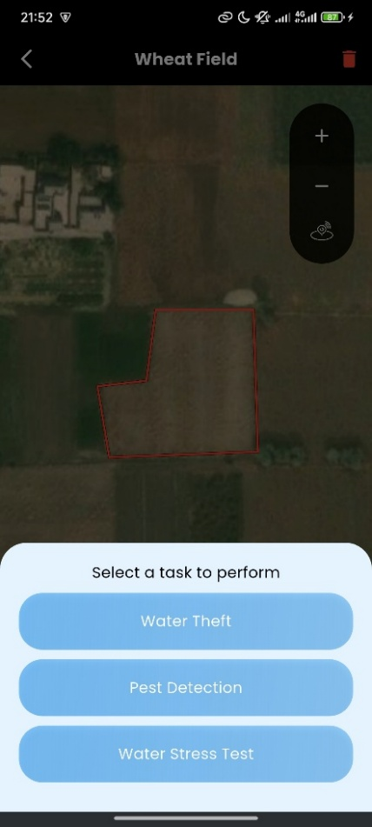 | 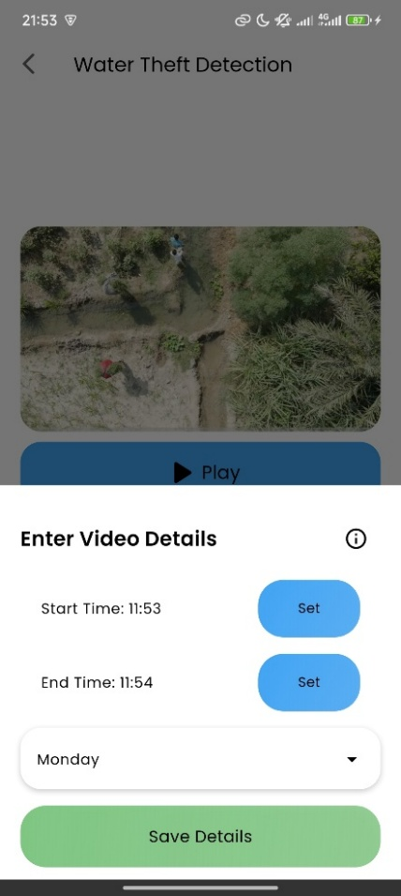
(a) | (b)
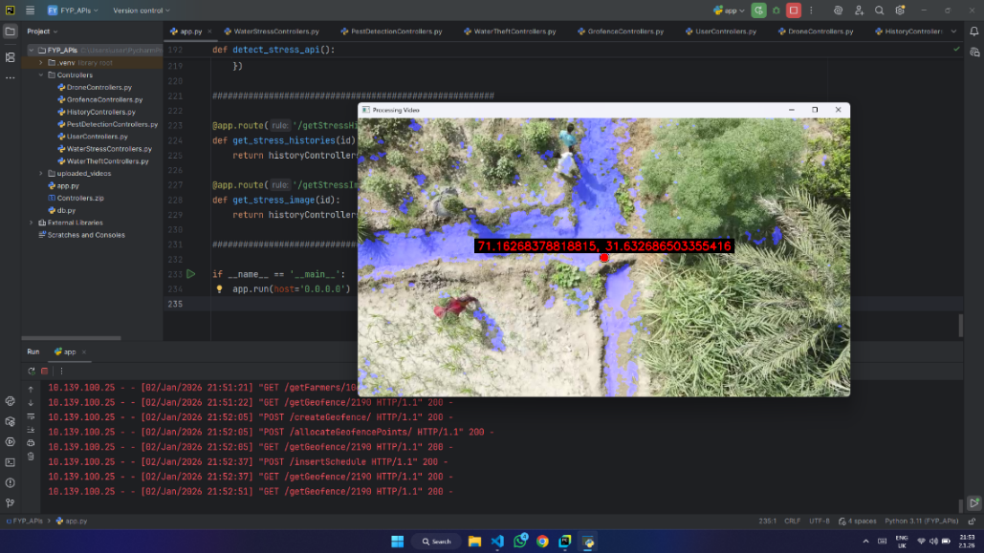
(c)
Figure 4.4: Perform Task Screen (a) Water Theft Detection Screen (b) Real Time Processing (Backend) (c)

Perform Task Screen:
This screen displays three main detection options: Water Theft Detection, Pest Detection, and Water Stress Test. User can select any task to proceed with video upload and analysis for the chosen detection type.
Water Theft Detection Screen:
This screen allows user to upload irrigation channel videos for analysis. User can play the video, set start time, end time, and operation day, then initiate real-time detection, and receive alert notifications if water theft is detected.

Real Time Processing:
This is the real-time processing screen. When the user uploads a video and presses on start, the video is uploaded to the backend server which processes it using Computer Vision Algorithms and stores the results in Database and returns them to the front-end.
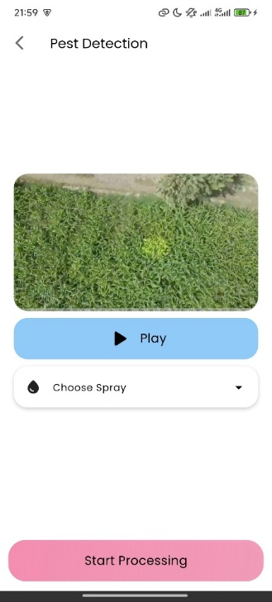 | 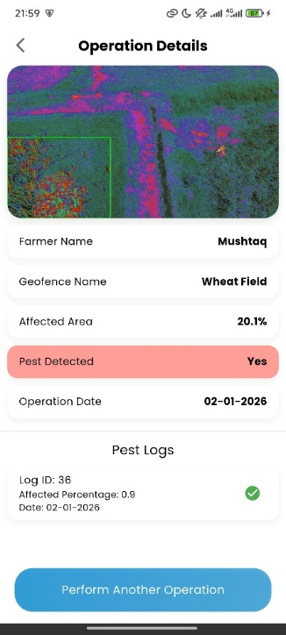 | 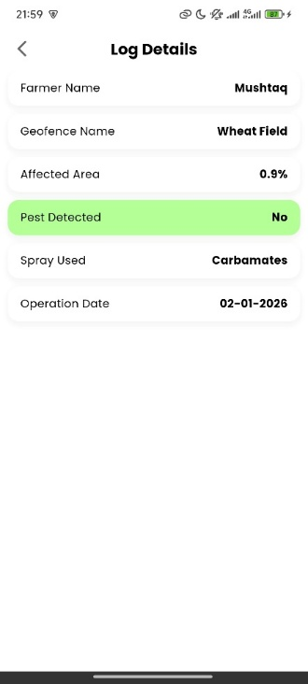
(a) | (b) | (c)
Figure 4.5: Pest Detection Screen (a) Operation Details Screen (b) Pest Log Details Screen (c)
Pest Detection Screen:
This screen allows users to upload a drone footage of the fields. Then the user chooses the spray type that was sprayed before the footage was recorded. The video is then uploaded to the Backend Server which processes it and detects the areas that are affected to the pests.
Operation Details Screen:
This screen shows the detailed results from pest detection operation. And allows users to add another log to the pest detection for the series of operations.

Pest Log Details Screen:
This screen shows the details of a log with name of the field, farmer of the field, affected area in percentage, detection status, spray used and the date when the operation was performed.
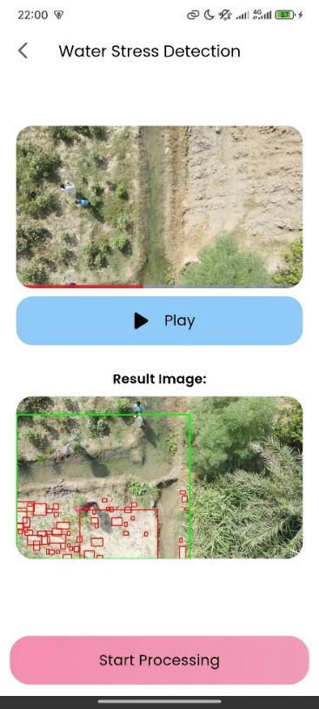 | 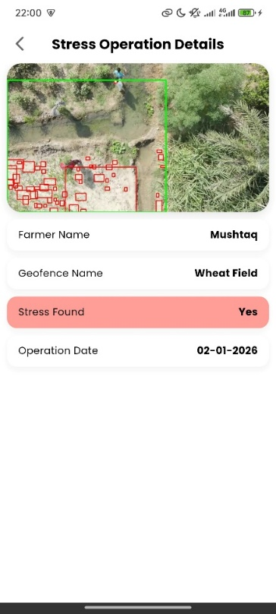
(a) | (b)
Figure 4.6: Water Stress Detection Screen (a) Operation Details Screen (b)
Water Stress Detection Screen:
This screen allows user to upload field videos for water stress analysis. User can play the video, initiate processing, view result images with NDVI/NDWI indices showing stressed zones with bounding boxes, and receive alert notifications if stress is detected.

Operation Details Screen:
This screen displays processed detection results including farmer name, geofence name, affected area percentage, detection status, and operation date. User can view detection overlays on images, access historical logs, and perform another operation directly from this screen.

Chapter 5
CONCLUSION

The concluding remarks and future directions for the development and up gradation of the existing projects are given below. Some of the limitations of the project are also given.

5.1 Conclusion Remarks
In conclusion, the "UAV-Based Agricultural Monitoring System" represents a significant stride in modernizing precision agriculture through intelligent automation and computer vision technology. By seamlessly integrating video-based analysis and incorporating features like water theft detection, pest detection, autonomous spray zone identification, and water stress mapping, the system addresses critical agricultural challenges faced by farmers. Its cross-platform mobile application and real-time processing capabilities provide a streamlined platform for monitoring large agricultural areas efficiently. The system's scalability and consideration for future enhancements, such as real-time drone integration and expanded pest species detection, underline its potential to become a comprehensive resource for farmers seeking data-driven agricultural management solutions.

5.2 Future Directions
In the future, the "UAV-Based Agricultural Monitoring System" could explore additional enhancements, such as incorporating real-time autonomous drone flight integration, expanding the pest detection model to cover 20+ additional species, introducing soil health analysis modules, implementing predictive analytics for early warning systems, enabling cloud-based deployment for multi-tenant support, and potentially integrating with government agricultural databases for broader impact assessment. These directions would further elevate the system's utility and adoption for large-scale precision agriculture across diverse farming communities.

5.3 Limitations
The "UAV-Based Agricultural Monitoring System" exhibits commendable features, yet it faces certain limitations. The system relies entirely on pre-recorded video footage for analysis, lacking real-time autonomous drone flight integration, which restricts immediate on-site detection capabilities. While the dataset is substantial at 42 GB, the models achieved 80% accuracy for water theft detection and 85% for pest detection, indicating room for improvement through expanded training data and additional pest species coverage. Addressing these limitations through real-time drone integration, model refinement with larger datasets, and enhanced detection accuracy under varying environmental conditions could significantly improve the system's overall performance and reliability in diverse agricultural scenarios.

REFERENCES
[1] Ahmed, S. (2024). Water Theft Detection in Irrigation Systems Using Thermal and RGB Imaging. International Journal of Agricultural Engineering, 12(1), pp. 45-58.
[2] Chen, L. (2023). UAV-Based Precision Agriculture: A Comprehensive Review. IEEE Access, 11, pp. 5234-5248. Retrieved from https://ieeexplore.ieee.org/document/10045678.
[3] Khan, A. (2024). Precision Agriculture Through UAV-Based Monitoring: Current Trends and Future Directions. Computers and Electronics in Agriculture, 195, pp. 106-120.
[4] Kumar, R. (2023). Deep Learning for Pest Detection in Agriculture Using Convolutional Neural Networks. Journal of Agricultural Technology, 19(4), pp. 112-125.
[5] Liu, X. (2023). Real-Time Video Processing for Agricultural Surveillance Systems. Journal of Computer Vision Applications, 22(3), pp. 201-215. Retrieved from https://link.springer.com/article/10.1007/s11263-023-01234-5.
[6] Martinez, J. (2024). Water Stress Detection Using NDVI and NDWI Indices from Multispectral Imagery. Remote Sensing in Agriculture, 15(2), pp. 78-92. Retrieved from https://www.mdpi.com/2072-4292/15/2/450.
[7] Patel, M. (2023). Flask API Development for Machine Learning Model Deployment. Retrieved from https://www.towardsdatascience.com/flask-api-ml-deployment-2023-4a5d7e89.
[8] Sharma, A. (2023). YOLOv8 for Real-Time Object Detection in Agricultural Monitoring. Retrieved from https://arxiv.org/abs/2301.12345.
[9] Williams, R. (2023). Mobile Application Development for Agricultural Monitoring Using Flutter and React Native. Retrieved from https://medium.com/@rwilliams/mobile-agri-apps-2023-7f8a9d12.
[10] Zhang, Y. (2023). Computer Vision Applications in Smart Farming: Challenges and Solutions. Agricultural Systems, 208, pp. 103-118.

ANNEXURE
Annexure A: Login and Dashboard Navigation
Step 1: User enters credentials on the Login Screen.

Step 2: Depending on the user's action: If User enters valid 'Username' and 'Password,' the application authenticates the user and navigates to the Dashboard Screen.
If User selects 'Register Button,' the application navigates to the Registration Screen.
If credentials are invalid, the application displays "Invalid Username or Password" message.
Step 3: On Dashboard Screen, user views real-time statistics including Water Thefts, Pests Detected, Water Stress Areas, Available Drones, and Registered Farmers.
If User selects 'View All' under Water Thefts Section, the application navigates to Water Theft History Screen. If User selects 'View All' under Pest History Section, the application navigates to Pest History Screen. If User selects 'View All' under Water Stress Section, the application navigates to Water Stress History Screen.

Annexure B: My Drone Screen Management
Step 1: User interacts with the My Drones Screen.
Step 2: Depending on the user's interaction: If User selects 'Filter Drones Dropdown,' the application displays filter options: All, Available, Unavailable. If User selects a filter option, the drone list is filtered by the selected status. If User selects a 'Drone Card,' the application navigates to the Drone Details Screen. If User selects 'Add Drone Button,' the application navigates to the Add Drone Screen.
Step 3: In Add Drone Screen: If User enters Drone Name, Range, and Capacity details, the drone is saved to the database with AdminID. If fields are incomplete, the application displays "Please fill all fields" message.

Annexure C: Farmers and Geofence Management
Step 1: User interacts with the Farmers Screen.
Step 2: If User selects a 'Farmer Card,' the application navigates to the Farmer Details Screen displaying farmer information and allocated geofences.
Step 3: In Farmer Details Screen: If User selects 'Geofence Card' and then 'View Details,' the application navigates to the Geofence Details Screen. If User selects 'Allocate Geofence Button,' the application navigates to the New Geofence Creation Screen. If User selects 'Delete Farmer Icon,' a confirmation dialog is displayed, and upon confirmation, the farmer and associated geofences are deleted.

Annexure D: Geofence Creation and Task Scheduling
Step 1: User interacts with the New Geofence Screen.
Step 2: Depending on the user's interaction: If User draws a polygon on the map, the geofence boundary points are stored. If User enters a 'Geofence Name,' the field name is saved. If User selects 'Allocate Button,' the geofence is saved to the database with FarmerID and the application navigates to Geofence Details Screen. If User selects 'Clear Markers Button,' all drawn boundaries are cleared and the map is reset.

Step 3: In Geofence Details Screen: If User selects 'Set Button' for Start Time or End Time, a time picker is opened and the selected time is stored. If User selects 'Allocate Day & Time Button,' the schedule is saved and the application navigates to Task Selection Screen. If User selects 'Perform Tasks Button,' the application directly navigates to Task Selection Screen.

Annexure E: Task Selection and Water Theft Detection
Step 1: User interacts with the Task Selection Screen.
Step 2: Depending on the user's selection: If User selects 'Water Theft Detection,' the application navigates to the Water Theft Detection Screen. If User selects 'Pest Detection,' the application navigates to the Pest Detection Screen. If User selects 'Water Stress Test,' the application navigates to the Water Stress Detection Screen.

Step 3: In Water Theft Detection Screen: If User selects 'Play Button,' the uploaded video is played. If User sets Start Time, End Time, and Day, the details are stored. If User selects 'Save Details Button,' the video is sent to Flask API for processing, YOLOv8 Water Theft Model is executed, and real-time detection results are generated. If theft is detected, an alert notification is sent to the admin and "Water Theft Detected - Alert Sent" message is displayed.

Annexure F: Pest Detection and Spraying Operations
Step 1: User interacts with the Pest Detection Screen.
Step 2: If User selects 'Start Processing Button,' the video is sent to Flask API, YOLOv8 Pest Detection Model is executed, and affected area percentage is calculated in real-time.
Step 3: Result image with detection overlay and affected area percentage is displayed. If pest is detected, an alert notification is sent to the admin. If User selects a 'Pest Log,' the application navigates to Log Details Screen displaying farmer name, geofence name, affected area, pest status, spray used, and operation date.
Step 4: In Pest Spraying Screen: If User selects a 'Spray Type' from the dropdown and selects 'Start Processing Button,' infested zones are identified, spray zone map is generated, required spray volume is calculated, and spray log is saved.

Annexure E: Water Stress Detection and Navigation Menu
Step 1: User interacts with the Water Stress Detection Screen.

Step 2: If User selects 'Start Processing Button,' the video is sent to Flask API, NDVI and NDWI indices are computed, stressed zones are identified, and stress heatmap is generated in real-time.

Step 3: Result image with stress zones and bounding boxes is displayed. If stress is detected, an alert notification is sent to the admin and "Water Stress Detected - Alert Sent" message is displayed.
Step 4: In Hamburger (Nav) Menu: If User selects 'Profile,' the application navigates to the Profile Screen. If User selects 'Settings,' the application navigates to the Settings Screen. If User selects 'Notifications,' the application navigates to the Notifications Screen. If User selects 'About Us,' the application navigates to the About Us Screen. If User selects 'Logout,' a confirmation dialog is displayed, and upon confirmation, the session is cleared and the application navigates to the Login Screen.

